State of Nebraska

Department of Health and Human Services

REQUEST FOR INFORMATION

REQUEST FOR INFORMATION (RFI) | RELEASE DATE
RFI Medicaid and Long-Term Care Data Management and Analytics | May 1, 2024
DUE DATE AND TIME | PROCUREMENT CONTACT
June 6, 2024, 2:00 p.m. Central Time | Carrie DeFreece,  Procurement Contracts Officer
This form must be signed manually in ink or by DocuSign and returned, along with information and documents, by the date and time specified.
PLEASE READ CAREFULLY!
DISCLAIMER: This notice is for informational purposes only. This is not a request for proposal or
quote. It does not constitute a solicitation and shall not be construed as a commitment by the State of Nebraska. Responses in any form are not offers and the State of Nebraska is under no obligation to award a contract as a result this announcement. No funds are available to pay for the preparation of responses to this announcement. Any information submitted by respondents is strictly voluntary.

INTRODUCTION: Responses to the Request for Information (RFI) may be used to formulate final requirements and/or to identify qualified vendors capable of meeting those requirements. The description herein outlines preliminary requirements envisioned in the management of data and analytic services for the State of Nebraska Department of Health and Human Services (DHHS), Division of Medicaid and Long-Term Care (MLTC). The information gathered may be used to formulate acquisition strategies for competitive solicitations.

BACKGROUND: The State of Nebraska (State), Department of Health and Human Services (DHHS), Medicaid and Long-Term Care Division (MLTC) is gathering information to understand what capabilities exist in the area of Medicaid Data Management and Analytics Services to inform Medicaid Enterprise System (MES) planning efforts.

ALL INFORMATION PERTINENT TO THIS REQUEST FOR INFORMATION CAN BE FOUND AT: https://das.nebraska.gov/materiel/bidopps.html

TABLE OF CONTENTS

TABLE OF CONTENTS ii
I. SCOPE OF THE REQUEST FOR INFORMATION 1
A. SCHEDULE OF EVENTS 1
II. RFI RESPONSE PROCEDURES 2
A. OFFICE AND CONTACT PERSON 2
B. GENERAL INFORMATION 2
C. COMMUNICATION WITH STATE STAFF 2
D. WRITTEN QUESTIONS AND ANSWERS 2
E. ORAL INTERVIEWS/PRESENTATIONS AND/OR DEMONSTRATIONS 3
F. SUBMISSION OF RESPONSE 3
G. PROPRIETARY INFORMATION 3
III. PROJECT DESCRIPTION AND SCOPE OF WORK 4
A. PURPOSE AND BACKGROUND 4
B. MEDICAID DATA AND ANALYTICS OPERATIONS 5
C. RESPONDENT REQUIREMENTS 10
D. PRICING 15
E. VENDOR OVERVIEW 15
Form A Vendor Contact Sheet 17

- SCOPE OF THE REQUEST FOR INFORMATION

The State of Nebraska, Department of Health and Human Services, Division of Medicaid and Long-Term Care (MLTC), hereafter known as the State, is issuing this Request for Information, RFI MLTC Data Management and Analytics, for the purpose of gathering information regarding companies interested in providing Medicaid data analytics, reporting, and processing options for State consideration. Information gained through the RFI may be used to direct possible future procurement processes.

  - SCHEDULE OF EVENTS
The State expects to adhere to the tentative procurement schedule shown below. It should be noted, however, that some dates are approximate and subject to change.

NOTE: All ShareFile links in the Schedule of Events below, are unique links for each schedule step. Please click the correct link for the upload step you are requesting.

ACTIVITY |  | DATE/TIME
1 | Release Request for Information | May 1, 2024
2 | Last day to submit written questions.  ShareFile link for uploading questions:  https://nebraska.sharefile.com/r-rf123581034c7408e8681c2d7b4e5b362 | May 14, 2024
3 | State responds to written questions through Request for Information “Addendum” and/or “Amendment” to be posted to the internet at:  https://das.nebraska.gov/materiel/bidopps.html | May 21, 2024
4 | RFI DUE – Online Via WebEx  IT IS THE RESPONDENT’S RESPONSIBILTY TO UPLOAD ELECTRONIC FILES BY DUE DATE AND TIME. EXCEPTIONS WILL NOT BE MADE FOR TECHNOLOGY ISSUES.  ShareFile Electronic Proposal Submission Link:  https://nebraska.sharefile.com/r-rf123581034c7408e8681c2d7b4e5b362  Join WebEx Meeting  https://sonvideo.webex.com/sonvideo/j.php?MTID=m04fc9d673bf0e4bb49312ca21bd9e5d2 | June 6, 2024  2:00 PM  Central Time
5 | The State reserves the right to conduct oral interviews at the sole invitation of the State. | TBD

- RFI RESPONSE PROCEDURES

  - OFFICE AND CONTACT PERSON
Responsibilities related to this RFI reside with the Department of Health and Human Services. The point of contact for the RFI is as follows:

Name: Carrie DeFreece, Procurement Contracts Officer
Agency: DHHS Office of Procurement and Grants
Address: Nebraska State Office Building
301 Centennial Mall South, 5th Floor
Lincoln, NE 68509
Telephone: 402-471-0904
E-Mail: Carrie.DeFreece@nebraska.gov
DHHS.RFPquestions@nebraska.gov

  - GENERAL INFORMATION
There is no commitment by the State of Nebraska to issue a solicitation as a result of this RFI. This is being issued solely for informational and planning purposes and does not constitute a solicitation. Responses to this notice are not offers and cannot be accepted by the State of Nebraska to form a binding contract. This is not a request for proposal or quote. It does not constitute a solicitation and shall not be construed as a commitment by the State. Responses in any form are not offers and the State is under no obligation to award a contract as a result of this announcement. No funds are available to pay for preparation of responses to the announcement. Any information submitted by respondents is strictly voluntary.

  - COMMUNICATION WITH STATE STAFF
Communications regarding this RFI between respondents and individuals employed by the State should be restricted to written communication with the staff designated above in paragraph II. A. The following exceptions to these restrictions are permitted:
    - Contacts made pursuant to any pre-existing contracts or obligations; and
    - State-requested presentations, key personnel interviews, clarification sessions, or discussions.

The State of Nebraska will issue any clarifications or opinions regarding this RFI in writing.

  - WRITTEN QUESTIONS AND ANSWERS
Questions regarding the meaning or interpretation of any Request for Information provision should be submitted in writing to State of Nebraska Department of Health and Human Services, Office of Procurement and Grants and clearly marked “RFI: MLTC Data Management and Analytics; Application Questions”. It is preferred that questions be submitted via ShareFile link in Schedule of Events (Section I.A.)

It is recommended that vendors submit questions using the following format.

Question Number | RFI Section Reference | RFI Page Number | Question

Written answers will be posted at https://das.nebraska.gov/materiel/bidopps.html on or before the date shown in the Schedule of Events.

  - ORAL INTERVIEWS/PRESENTATIONS AND/OR DEMONSTRATIONS
The State may conclude that oral interviews/presentations and/or demonstrations are needed for clarification or understanding. Oral interviews are at the sole invitation of the State and may not be needed of all respondents.

Any cost incidental to the oral interviews/presentations and/or demonstrations shall be borne entirely by the vendor and will not be compensated by the State.

  - SUBMISSION OF RESPONSE
The State is only accepting electronic responses submitted in accordance with this RFI. The State will not accept responses by mail, email, voice, or telephone, unless otherwise explicitly stated in writing by the State.

It is the responsibility of the vendor to check the website for all information relevant to this RFI to include addenda and/or amendments issued prior to the opening date. The website can be found here: https://das.nebraska.gov/materiel/bidopps.html.

WHAT SHOULD BE INCLUDED IN YOUR RESPONSE:

    - Do submit succinct, thoughtful responses to the requirements/questions listed in this RFI.
    - Do submit comments that address the State’s requirements, assumptions, conditions, or contemplated approaches to this requirement.
    - Do submit information and suggestions that may encourage new, different, or innovative approaches that would result in products, solutions, and direct savings to the State of Nebraska.

  - PROPRIETARY INFORMATION
Data contained in the response and all documentation provided therein, become the property of the State of Nebraska and the data becomes public information upon opening the response. If the respondent wishes to have any information withheld from the public, such information must fall within the definition of proprietary information contained within Nebraska’s public record statutes. All proprietary information the respondent wishes the State to withhold must be submitted marked proprietary. Failure of the respondent to follow the instructions for submitting proprietary and copyrighted information may result in the information being viewed by other respondents and the public. Proprietary information is defined as trade secrets, academic and scientific research work which is in progress and unpublished, and other information which if released would give advantage to business competitors and serve no public purpose (see Neb. Rev. Stat. § 84-712.05(3)). In accordance with Attorney General Opinions 92068 and 97033, vendors submitting information as proprietary may be required to prove specific, named competitor(s) who would be advantaged by release of the information and the specific advantage the competitor(s) would receive. Although every effort will be made to withhold information that is properly submitted as proprietary and meets the State’s definition of proprietary information, as determined by the State, the State is under no obligation to maintain the confidentiality of proprietary information and accepts no liability for the release of such information.

- PROJECT DESCRIPTION AND SCOPE OF WORK
The State of Nebraska is issuing this RFI for the purpose of gathering information regarding companies interested in providing Medicaid data analytics, reporting, and processing options for State consideration.

  - PURPOSE AND BACKGROUND
The Nebraska Department of Health and Human Services (DHHS) is issuing a request for information to inform the planning, design, development, and implementation of the State’s Medicaid Enterprise System (MES) modernization and optimization strategy. Nebraska seeks to develop a strategy and roadmap that focuses on modularity, Return on Investment (ROI), opportunities for reuse, and value for the Medicaid beneficiary.

The first priority for Nebraska is replacement of the State’s incumbent Data Management and Analytics (DMA) solution. This legacy system includes multiple modules, and serves the following key functions for the State:
- Managed Care Organization (MCO) encounter claims processing, acceptance, and validation;
- Medicaid Data Warehouse and Analytics;
- Pre-built and ad-hoc reporting, including federal financial reporting;
- Transformed Medicaid Statistical Information System (T-MSIS) reporting; and
- Program Integrity Case Management (PICM) platform used for Fraud, Waste, and Abuse investigations (FWA), and Fraud Detection and Analytics reporting.

The first step in the process of replacing the existing solution is a comprehensive evaluation of the relevant market landscape to determine alternative options currently available and utilized in other states. The State is seeking information from potential vendors to identify solutions that can replace our incumbent system and meet our objectives efficiently and effectively. This document outlines our scope, requirements, and expectations. We encourage vendors to provide detailed responses that comprehensively address our needs mentioned below in the key areas of examination.

Based on analysis and the RFI process, the State expects to develop a competitive solicitation for one or more Commercial off the Shelf (COTS) solutions without the need for a custom build. Furthermore, the solution(s) is expected to have strong administrative capabilities that provide the ability to configure the solution, thus limiting custom coding. Nebraska is also particularly interested in opportunities for reuse and solutions that have successfully completed or who have successful experience with the Centers for Medicare & Medicaid (CMS) Certification process.

The State is seeking information on the following areas of functionality that are of particular interest. Respondents are not expected to possess capabilities in all areas but should provide a detailed response to the areas of examination in which they are able to provide service.

Areas of Examination:
- Enterprise Data Warehouse (EDW)
- Transformed Medicaid Statistical Information System (T-MSIS)
- Encounter Claims Processing System
- Program Integrity Case Management (PICM)
- Data Analytics
- Integration capabilities and experience
- Reporting and report automation
- Training methodologies and ongoing support
- Resourcing and staffing strategies
- Operational support capabilities
- Operational Change Management (OCM)

  - MEDICAID DATA AND ANALYTICS OPERATIONS

    - PROGRAM OVERVIEW
The Nebraska Medicaid program provides physical health, behavioral health, dental, and pharmacy benefits to approximately 363,044 residents. The majority of services are administered through the Nebraska Medicaid Managed Care Program known as Heritage Health. Currently, the State contracts with three MCOs who are responsible for service delivery statewide. The Medicaid program also provides Fee-For-Service (FFS) claims in addition to the MCO services, including both Waiver and Nursing Facility (NF) services. Medicaid Expansion became effective October 1, 2020, which expanded coverage to previously ineligible adults with incomes up to 138% of the federal poverty level, under the provisions of the Patient Protection and Affordable Care Act (PPACA).

The State understands that it is critical to make data-driven decisions to maximize the value offered to our Medicaid population while honoring our responsibility to taxpayers to optimize our financial resources. As such, we seek to understand and evaluate the value being derived from our existing solutions and utilize this information to guide future planning.

The State currently utilizes the DMA solution to complete MCO encounter claim, receipt, and data validation processing. This solution also hosts:
- the State’s data warehouse/decision support system (DW/DSS),
- T-MSIS reporting platform,
- Program Integrity Case Management (PICM) system, and
- fraud abuse detection system and analytics.
Nebraska is seeking a replacement solution or combination of solutions to meet these needs. The FFS claims remaining in the State are processed by the State’s legacy system. FFS claims processing is not within the scope of this RFI.

DHHS and Centers for Medicare & Medicaid (CMS) have emphasized the importance of a modular strategy to MES optimization focusing on implementing functional or technical modules that can be plugged in or replaced quickly. Modularity will enhance business agility, provide faster delivery of new functionality, and help maximize the value derived from each module. CMS and the State of Nebraska also place a high value on reuse opportunities.

    - CURRENT BUSINESS PRACTICES
The underlying premise of the incumbent Nebraska Data Management and Analytics solution was to make the data universe available to a broader user base; allowing team members to more readily view and interact with the data. This supports reduction of dependencies on dedicated business units to obtain and provide data/reports. Further, the solution includes data analytics, investigative case management, encounter claim processing, and support for T-MSIS. When evaluating replacement options for the incumbent solution, Nebraska is prioritizing modularity and is interested in considering a comprehensive range of data management and analytics offerings that will maintain or expand the current range of functionality.

Medicaid administrative functions supported by the current solution include:

      - REPORTING
With the current solution, users may access, schedule, and export standard “canned/pre-defined” reports via the Analytics Software Solution. The report functionality also allows for collaboration and the ability to define alert thresholds for summary reports. The Analytics Software Solution also has ability for users of all levels to create filtered and summarized views of the full data warehouse using simple filter criteria.

Ad-hoc reporting and validation of Analytics Software Solution report data is accomplished by querying the Integrated Database. Data is updated monthly. The integrated data layer of the data warehouse holds all data ingested from all sources and feeds the Analytics data layer. It is available for ad-hoc querying for higher-level users who need to perform more detailed analysis than the simple filter-style queries afforded by the Analytic Layer.

This arrangement has some limitations that the State would like to overcome with a new solution(s) -
- Directly querying the database requires a user to have an advanced skillset, limiting the number of users with access to all data sets.
- Only a portion of the data available in the Integrated Database is available in the Analytics Software Solution, which can cause variances in report data.
- Report layout changes cannot be made directly by the user.

      - PROGRAM INTEGRITY CASE MANAGEMENT (PICM)
PICM is a stand-alone module, used by the Program Integrity (PI) unit to:
- Create and manage case investigations;
- Associate possible fraud, erroneous payments, waste, and abuse cases with Providers/Members or Claims;
- Track specific case activities and action items via task management capabilities; and
- Generate case related summary and detail reporting.

Other PI functionality includes Surveillance and Utilization Review Subsystems (SURS) Exception Reporting and PI Algorithms, which are standard reports developed on known vulnerabilities in claims payment systems.

      - ENCOUNTER CLAIMS PROCESSING
The current solution performs validation and acceptance of managed care encounter claims before storing them in the data warehouse. Claims are received in 837 and NCPDP claim formats through the state's EDI gateway and aggregated into daily batches for ingestion by DMA. Strategic National Implementation Process (SNIP) editing is performed at the EDI gateway level.

DMA performs business rules validation by applying a set of state defined edits to each incoming encounter, including allowances for appropriately denied claims. Accepted claims are mapped from the native 837 or NCPDP format to the common data warehouse claims format used by existing data. Accept/reject responses and month-to-date acceptance statistics are routed back to the MCOs per batch via the state EDI gateway.

      - T-MSIS
Submitting T-MSIS data in compliance with federal timing and data quality standards is a critical priority of the Medicaid Program. The state uses DMA to build its monthly T-MSIS submissions from the data warehouse. The vendor is responsible for generating and submitting monthly T-MSIS files. This includes building and maintaining appropriate mapping logic from sources in the data warehouse to the T-MSIS format, per the specifications of the state. The vendor also supports the state in investigating data quality issues identified by CMS contractor and implementing logic changes to address those issues.

      - DATA ANALYTICS
The current solution allows users to query and perform analytics on claims, provider enrollment, and member enrollment data.

      - SYSTEM OVERVIEW
Currently, the State of Nebraska is using DMA solution, offered as a software-as-a-service (SaaS) solution. DMA capabilities include –

- Federal and Standard Reports: Supports the process and function of creating, maintaining, and delivering pre-built reports.
- Ad hoc Reports: Supports the functions and processes which facilitate ad hoc reporting and analysis by DMA users.
- Dashboards: Supports the capability for developing individual and organizational dashboards that incorporate multiple analyses to provide a particularized view of the different facets for a given subject area or analysis topic.
- Geospatial Analytics: The system allows for basic prebuilt mapping and adds latitude and longitude coordinates for some physical addresses.
- Data Extracts: This capability includes both individual end user capabilities of report delivery, scheduling, data mining and extraction through the application, as well as delivery of data through automated extracts to internal DHHS entities and external groups. One key external extract is Medicaid Drug Rebate (MDR) of Medicaid Management Information System (MMIS) claims history to prepare quarterly invoices for drug rebates from manufacturers.
- Program Integrity (PI): Data in a variety of formats can be captured, examined, consolidated, and reported on to manage and monitor FWA practices. PI component integrates with case management tracking functionality so that queries, reports, alerts, and other analytical functions can be tied to and into a case for investigation. The FADS and PI analytics component play a critical role in identifying potentially fraudulent activities within Medicaid programs, leveraging advanced data analytics, anomaly detection algorithms, and predictive modeling techniques to analyze vast datasets and detect irregular patterns indicative of fraud.
- Program Integrity Case Management (PICM): The ability to track and manage investigations. Users can log into a single user interface and can take queried results, alerts, or dashboard items and create or attribute them to investigations.
- Data Sources – Allows for multiple data source inputs from disparate systems and different formats to be loaded into the solution for analytics and reporting purposes.
- Medicaid Enterprise System (MES) Analytics – Medicaid analytics provide insight into key Medicaid operating metrics across each business area.
- Transformed Medicaid Statistical Information System (T-MSIS) – This extraction process provides a format for the submission that meets the requirements defined in T-MSIS. This component includes a T-MSIS data mart model, extract files, and operational dashboards for each subject area within the T-MSIS extract process. These dashboards support Nebraska’s ability to analyze information sent to the Centers for Medicare & Medicaid (CMS).
- Medicaid Administrative Reporting System (MARS) – This includes a MARS data mart model, reports, and dashboards in support of MARS activity.
- Surveillance Utilization Reporting System (SURS) – Includes reporting functionality in support of SURS activity.
- Enterprise Data Warehouse (EDW) Data Model for Healthcare –The EDW data model includes data sets, such as prior authorizations, health insurance premium payments, Medicaid transportation, clinical and labs, waivers, netted claims/encounters, and denied claims/encounters, integrated into a data warehouse model that tracks history of changes and serves as a single source of truth for health information.

Data types listed below are available in the DMA Production Environment. A new solution(s) would also be expected to include the following data types:
- Medical Claims
- Medical Encounters
- Home and Community Based Services (HCBS) Claims
- Pharmacy Claims
- Pharmacy Encounters
- Capitation Payments
- Member Eligibility
- Provider Enrollment
- Third Party Liability (TPL)
- Prior Authorization (PA)
- Federal Financial Reporting
- Estate Recovery Claims
- Estate Recovery Encounters
- Provider Ownership

    - SYSTEM ARCHITECTURE

Figure 1: Enterprise Architecture
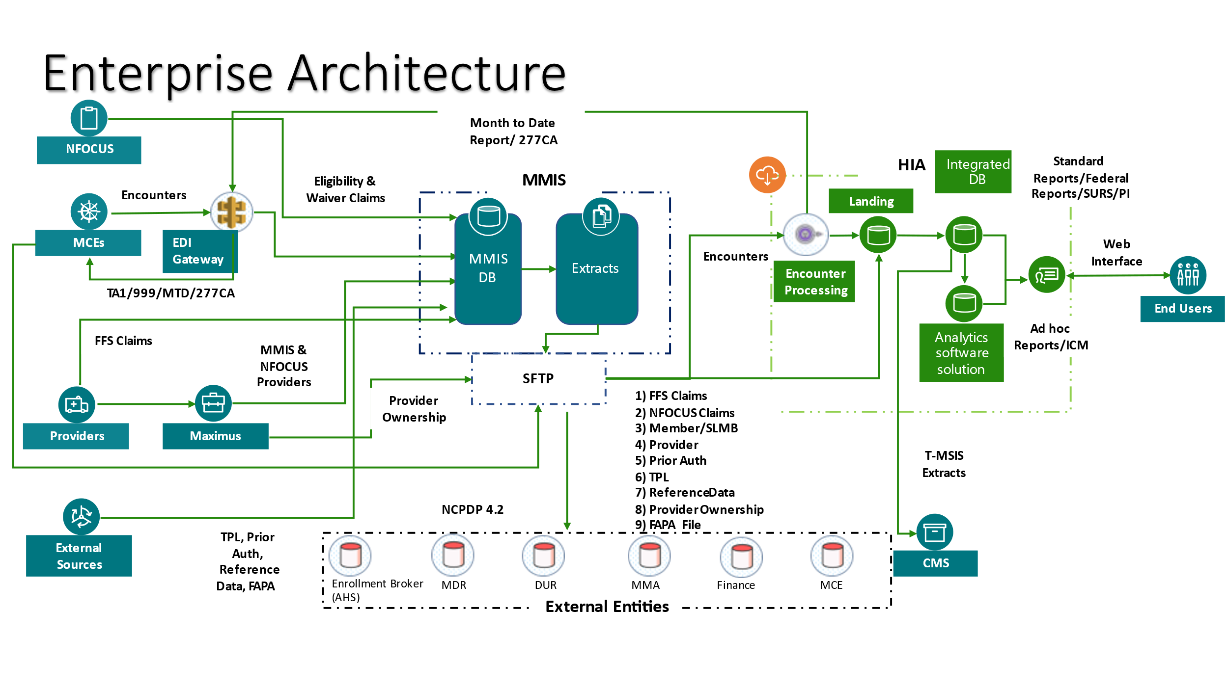

Figure 2: DMA Architecture
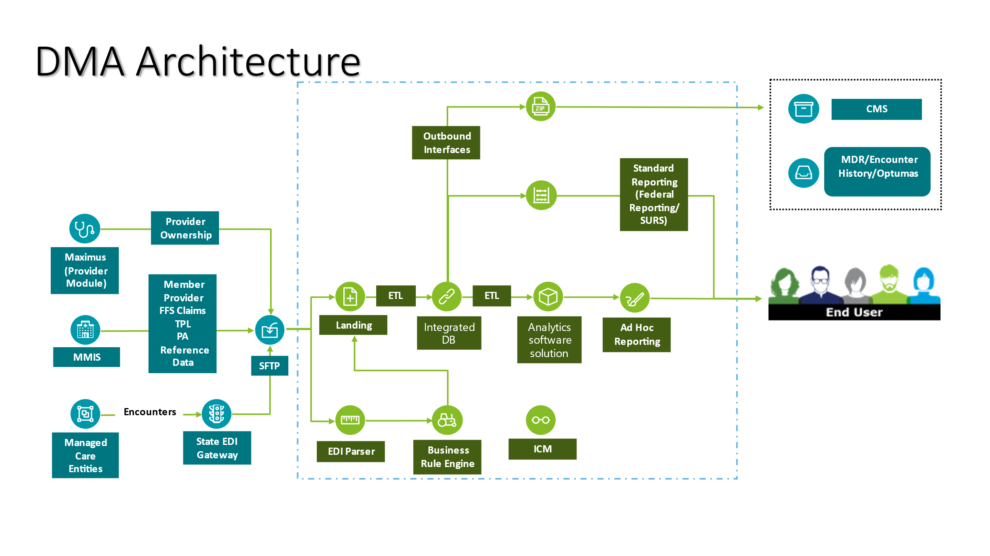

  - RESPONDENT REQUIREMENTS
Respondents may choose to provide narrative responses to any or all the following areas of examination :

Areas of Examination
- Enterprise Data Warehouse (EDW)
- Transformed Medicaid Statistical Information System (T-MSIS)
- Encounter Claims Processing System
- Program Integrity Case Management (PICM)
- Data Analytics
- Integration capabilities and experience
- Reporting and report automation
- Training methodologies and ongoing support
- Resourcing and staffing strategies
- Operational support capabilities
- Operational Change Management (OCM)
    - ENTERPRISE DATA WAREHOUSE
- Data Warehousing: Explain your approach for an Enterprise Data Warehouse and Data Analytics capabilities which can inform actionable insights for better decision making.
- Data Management: Describe your data management capabilities/functions, and how they are used to manage the data assets. Briefly explain your plan(s) for Data Governance, Data Architecture, Data Modeling, Data Storage, Data Sharing, Data Security, Data Audit and Control, Data Integration, Data Interoperability, Meta Data Management, Data Quality and Data Conversion.
- Data Accessibility and User Interface: Discuss user interface features, emphasizing user authentication, role-based access controls, and intuitive query tools to empower stakeholders with self-service access to relevant Medicaid data.
- Data Retention and Archiving: Briefly touch upon data retention and archiving policies, ensuring historical data retention, archival procedures, and compliance with data retention regulations while managing storage costs effectively.
Vendor Response to items 1.a. through 1.d. above:

    - T-MSIS
The Transformed Medicaid Statistical Information System (T-MSIS) is pivotal to our Medicaid system, offering data crucial for decision-making and program integrity. Vendors should provide insights into their proficiency with T-MSIS data, focusing on:

- Data Accessibility: Describe how your solution would enable the state to view and query past T-MSIS data submissions.
- Compliance with Data Mapping and Submission: Illustrate understanding and compliance with data mapping to T-MSIS layouts and submission requirements as per the Data Dictionary, detailing support tools or resources for accurate file submissions.
- Data Quality and Validation: Outline your strategies for maintaining T-MSIS data quality, including cleansing and error correction processes, and how you monitor data quality metrics to ensure data accuracy and reliability.
Vendor Response to items 2.a. through 2.c. above:

    - ENCOUNTER CLAIMS PROCESSING SYSTEM
Efficient encounter claims processing is essential for our Medicaid system's functionality. We seek vendors with proven expertise in:
- System Capacity and Scalability: Highlight your infrastructure's ability to manage high volumes of encounter claims data, detailing scalability, hardware specifications, and processing speeds. Include instances of effectively handling large data volumes and explain your methods for managing varying encounter claim data sizes, focusing on scalability, load balancing, and resource allocation.
- Encounter Claims Processing Approach: Clarify whether encounter claims processing is managed in-house or outsourced, emphasizing your in-house expertise, personnel skills, proprietary technology, and quality assurance practices.
- Quality Assurance and Regulatory Compliance: Describe your quality control and error management for encounter claims data, including compliance validation, SNIP editing, reconciliation, and real-time error resolution methods. Demonstrate compliance with CMS and Medicaid regulations, offering evidence of your solution's adherence to regulatory standards, including experience exchanging claim and response information in standard X12 and NCPDP formats.
Vendor Response to items 3.a. through 3.c. above:

    - PROGRAM INTEGRITY CASE MANAGEMENT (PICM)
- PICM Module Functionality: Vendors must detail the module's capabilities for creating, managing, and tracking fraud, waste, and abuse cases. This includes linking cases to entities such as providers and members for in-depth analysis.
- Case Management Efficiency: Highlight the module's features for efficient case oversight, such as task tracking and collaborative tools, which support thorough investigation processes and detailed reporting.
- Integration and Reporting: Discuss the seamless integration of the case management module with other PI systems to streamline investigations and reporting. Emphasize the solution's reporting functions, showcasing its effectiveness through analytics.
- Customization and Adaptability: Address the module's customization capabilities to meet specific organizational needs and compliance with changing regulations, focusing on configurable features and scalability to enhance PI efforts.
- FADS and PI Analytics: Provide an overview by highlighting crucial role in Medicaid fraud detection, Fraud and Abuse Detection Systems (FADS) and PI Analytics, leverage advanced analytics, anomaly detection, and predictive modeling to safeguard program integrity, minimize financial losses, and enable real-time monitoring for targeted interventions.
Vendor Response to items 4.a. through 4.e. above:

    - DATA ANALYTICS
- Current Analytics: Outline your analytics tools, emphasizing features like real-time processing and predictive analytics. Share success stories where these tools have positively impacted healthcare outcomes, showcasing their value in practical scenarios.
- Scalability and Flexibility: Explain your platform's scalability, demonstrating its ability to manage increasing data volumes and adapt to new requirements. Highlight past examples where your system met the growing needs of healthcare organizations.
- Data Governance and Security: Describe your approach to ensuring data governance and security, focusing on access controls, encryption, and compliance with healthcare regulations. Mention your auditing capabilities for data integrity and confidentiality.
- Continuous Enhancement: Show your commitment to staying aligned with current data analytics technology by detailing your involvement in research & development (R&D), industry collaboration, and how you incorporate user feedback to refine your solutions.
Vendor Response to items 5.a. through 5.e. above:

    - INTEGRATION CAPABILITIES
Our agency prioritizes seamless integration for interoperability and efficient data exchange. We seek detailed insights from vendors on integration capabilities, focusing on:
- Integration Expertise & State Collaboration: Showcase your experience with integrating healthcare solutions, particularly with data and analytics systems; detailing your collaborative strategies with State resources. Highlight past successes and methodologies for aligning with State objectives and navigating challenges.
- Technical and Security Standards: Ensure your solution aligns with our existing systems, adhering to healthcare standards and secure data exchange protocols. Explain your commitment to data security, including encryption and Health Insurance Portability and Accountability Act (HIPAA) compliance, and your solutions technical specifications for seamless integration.
- Interoperability and Scalable Solutions: Demonstrate compliance with interoperability frameworks like FHIR for effective external system communication. Address scalability and futureproofing, explaining how your approach supports growth and incorporates new functionalities over time.
- Support and Maintenance: Outline your ongoing support framework, detailing how you handle post-integration maintenance, address issues, and provide software updates and technical assistance.
Vendor Response to items 6.a. through 6.d. above:

    - REPORTING AND REPORT AUTOMATION
- Federal Reporting Automation: Highlight your expertise in automating submissions such as CMS 64 and CMS 37, detailing automation workflows, data extraction methods, and specific functionalities designed for Federal reporting efficiency. Share examples of adherence to Federal standards.
- User-Friendly Reporting Tools: Describe the development of accessible reporting interfaces, emphasizing customization, intuitive visualization, and interaction. Provide examples of easy-to-use reporting designs.
- Data Integrity and Validation: Outline your strategies for maintaining data accuracy, including validation, error detection, and reconciliation within your reports, ensuring reliable data amidst integration challenges.
- Regulatory Compliance: Confirm your solution’s compliance with HIPAA, Health Information Technology for Economic and Clinical Health (HITECH), and CMS guidelines, providing evidence of compliance and ongoing efforts to meet regulatory requirements.
Vendor Response to items 7.a. through 7.d. above:

    - TRAINING OUTLINE
- Pre-Implementation Training: Outline strategies for preparing users before launch, including training needs assessment, customized plans, and session details (timing, duration, content).
- Ongoing Training & Support: Describe ongoing training and support post-launch, detailing session frequency, formats, and support channels, plus addressing new training needs.
- Types of Training: Identify training tailored for various roles, from end-users to technical staff, including methods like instructor-led, e-learning, workshops, and train-the-trainer programs, with examples of materials.
- Resource Documentation: Describe the essential documents for system use and maintenance, including formats, accessibility, user manuals, technical guides, and frequently asked questions (FAQs) that are provided during implementation.
- Training Evaluation: Define how you implement feedback mechanisms to assess and enhance training effectiveness, detailing evaluation methods, feedback analysis, and improvement incorporation.
Vendor Response to items 8.a. through 8.e. above:

    - RESOURCING AND STAFFING STRATEGIES
- Vendor Expertise: Vendors should detail their team’s qualifications and experience with similar projects, showcasing their ability to deliver effectively.
- Resource Management: Outline the approach to allocating resources and managing projects, ensuring tasks are prioritized, workloads managed, and contingency plans are in place.
- Scalability and Flexibility: Demonstrate the ability to adjust resources as project demands change, including scaling staff up or down and integrating specialized skills as needed.
- Staff Retention and Training: Highlight strategies for retaining staff and investing in their development to maintain a skilled and consistent team.
- Effective Communication: Ensure clear protocols for regular updates, issue escalation, and collaborative decision-making with stakeholders for project transparency and alignment.
Vendor Response to items 9.a. through 9.e. above:

    - OPERATIONS SUPPORT
- 24/7 Monitoring & Rapid Incident Management: Ensure system reliability with continuous monitoring, quick issue detection, and fast resolution, detailing tools used, escalation processes, and response times.
- Optimization & Incident Handling: Describe strategies for system performance tuning and efficient incident management, including resolution processes, robust testing, and performance improvement examples.
- Updates & Continuity Planning: Explain patch management for security and functionality, alongside robust disaster recovery strategies to protect data and minimize outages, detailing patch testing, data backup, and failover mechanisms.
- Support Documentation & Training: Highlight documentation practices for system maintenance and knowledge transfer methods, including training for our staff to independently support the system.
Vendor Response to items 10.a. through 10.d. above:

    - OCM (ORGANIZATIONAL CHANGE MANAGEMENT)
- Support for Change Management: Show your capability to assist in navigating and adopting changes to achieve desired business outcomes. Include successful case studies of change support in relevant projects.
- Engagement and Communication: Highlight your methods for effective stakeholder communication, ensuring teams are informed and ready for change. Share communication tactics and tools that have proven successful in stakeholder engagement.
- Key OCM Support Offerings: Outline your offerings, such as impact assessments, stakeholder engagement, training, readiness, and reporting. Explain your proficiency with methodologies like Prosci for efficiently guiding stakeholders from current to future- states.
- Methodology and Approach: Describe how you tailor OCM strategies to fit the unique needs of each project, providing examples of adaptive methodologies for various industry requirements.
Vendor Response to items 11.a. through 11.d. above:

  - PRICING
Describe respondents pricing structure and how specific services are billed. These pricing structures should include an explanation of the industry standard pricing structure for items such as, but not limited to, fees for service, hourly rates, service categories, design and development, implementation; licensing, maintenance, enhancement, and hosting fees; help desk feature fees, module fees, etc.
Vendor Response (show a sample layout of a billing document):
  - VENDOR OVERVIEW

- Include a brief overview of respondent’s organization, number of years in business, and an overview of the key personnel involved in the applicable services.
Vendor Response:
- Describe any similar work performed for state or local government agencies.
Vendor Response:

- Describe any other entities respondent uses in the provisions of services, and whether they are an affiliate, third-party service provider, subcontractor, etc.
Vendor Response:
- Provide any additional information respondent believes would be beneficial to the State regarding options Data and Analytics Management.
Vendor Response:

Form A
Vendor Contact Sheet

Request for Information Number MLTC Data and Analytics Management

Form A should be completed and submitted with the response to this RFI document.

Primary Respondent Point of Contact
Vendor Name:
Vendor Address:
Contact Person & Title:
E-mail Address:
Telephone Number (Office):
Telephone Number (Cellular):
Fax Number:

Secondary Respondent Point of Contact

Vendor Name:
Vendor Address:
Contact Person & Title:
E-mail Address:
Telephone Number (Office):
Telephone Number (Cellular):
Fax Number:

